Q1. Create a New Database and Table for Employees Task: Create a new database named company_db and Create a table named employees with the following columns:
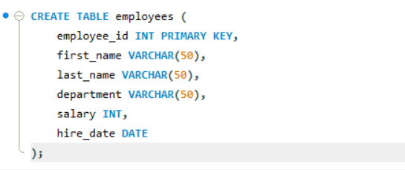

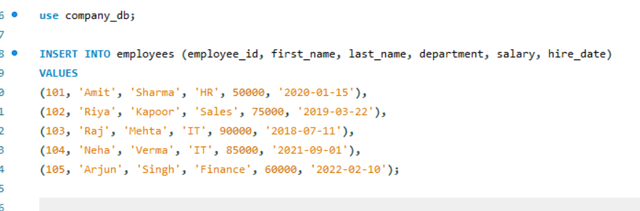
2. Insert the following sample records into the employees table.

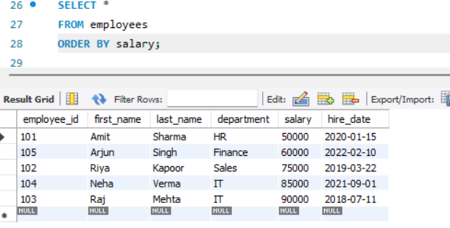
3. Display All Employee Records Sorted by Salary (Lowest to Highest)

4. Show Employees Sorted by Department (A–Z) and Salary (High → Low)
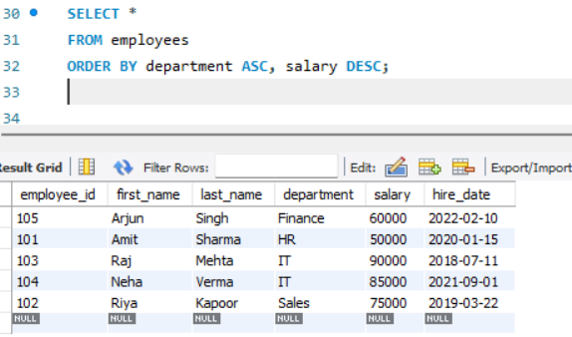

6. List All Employees in the IT Department, Ordered by Hire Date (Newest First)

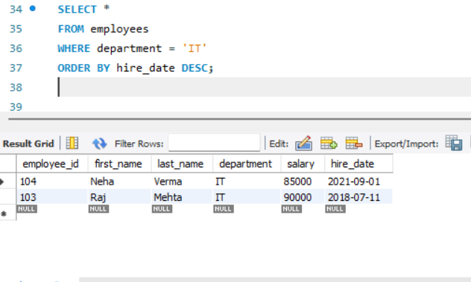

6. Create and Populate a Sales Table
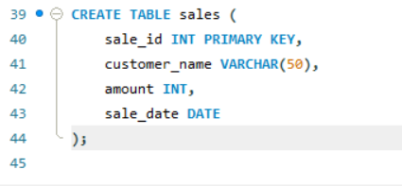

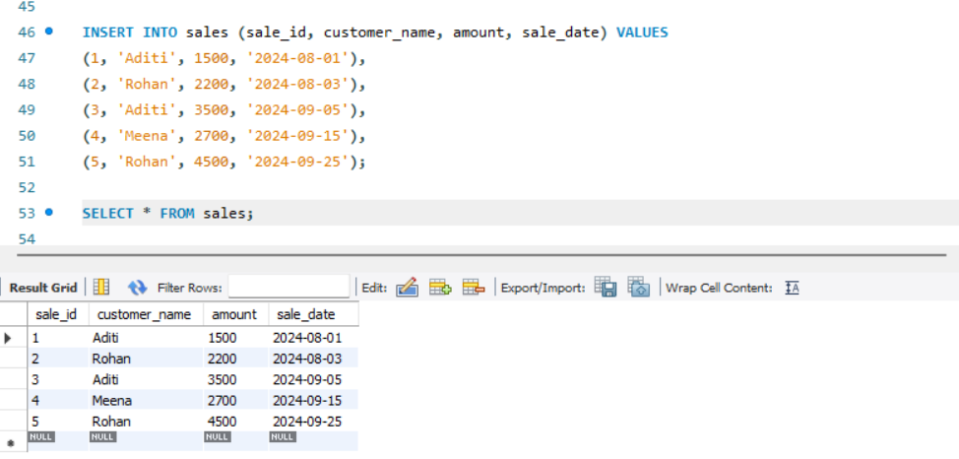
7. Display All Sales Records Sorted by Amount (Highest → Lowest)
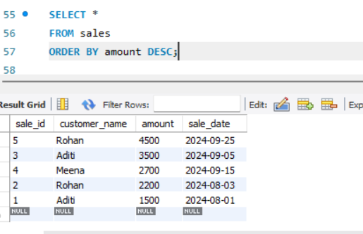

8. Show All Sales Made by Customer “Aditi”

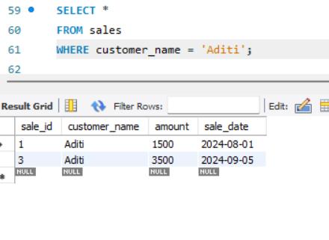
9. What is the Difference Between a Primary Key and a Foreign Key?

Primary Key
- Uniquely identifies each record in a table
- Cannot have NULL values
- Must be unique
- Only one primary key per table (can be composite)
Example:
Sale_id INT PRIMARY KEY
Foreign Key
- Used to link one table to another
- Refers to a primary key in another table
- Can have duplicate values
- Can contain NULL (unless restricted)
Example:
customer_id INT,
FOREIGN KEY (customer_id) REFERENCES customers(customer_id)
Key Difference:
- Primary Key = identity of a record
- Foreign Key = relationship between tables

Q10. What Are Constraints in SQL and Why Are They Used?
- Constraints are rules applied to table columns to control the type and validity of data.
🔹 Common Types of Constraints:
- PRIMARY KEY → Unique + Not Null
- FOREIGN KEY → Maintains relationships
- NOT NULL → Prevents empty values
- UNIQUE → No duplicate values
- CHECK → Ensures a condition (e.g., salary > 0)
- DEFAULT → Sets a default value
Example:
CREATE TABLE employees (
emp_id INT PRIMARY KEY,
name VARCHAR(50) NOT NULL,
salary INT CHECK (salary > 0),
department VARCHAR(50) DEFAULT 'General');
Why Constraints Are Used:
- Ensure data accuracy
- Maintain data integrity
- Prevent invalid or duplicate data
- Enforce business rules

